1. Review from p.3 to p.13 in the text book.

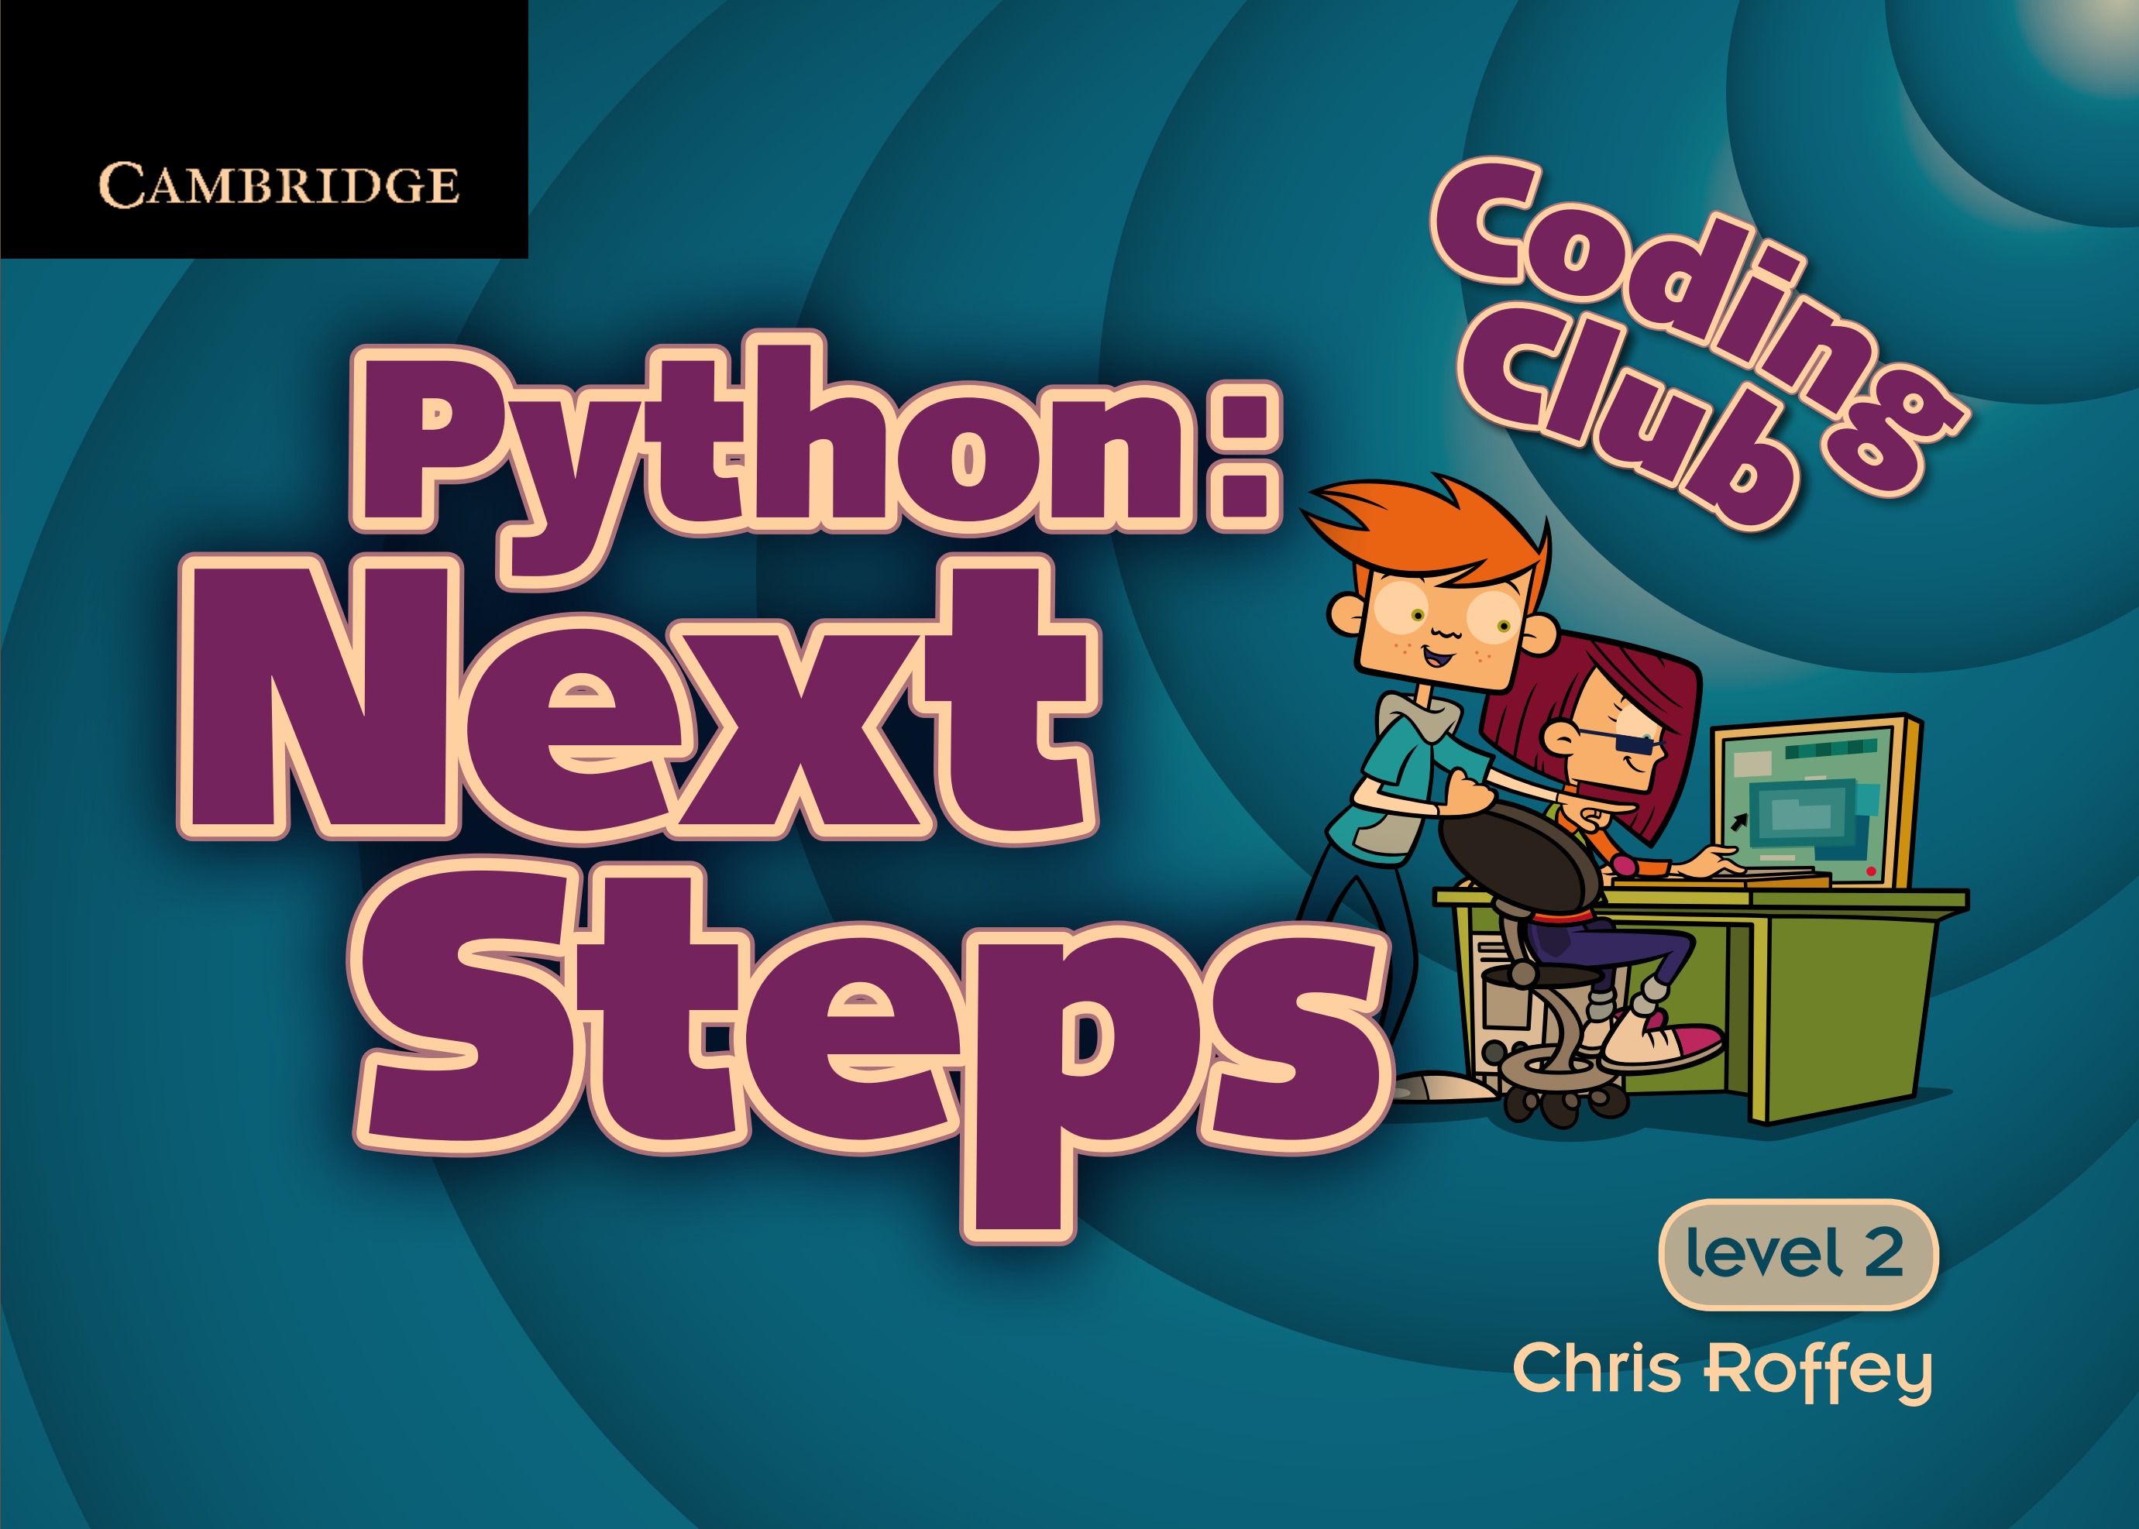

1. Summarize the concepts you think are important among those contents.